Armée de Terre
Académie militaire de Saint-Cyr Coëtquidan
Direction des Études

Robotics Seminar 2024

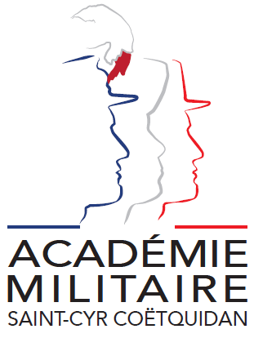

ERASMUS ID CODE | FGUER01
Contact | Information on lectures: Yves BERGEON (yves.bergeon@st-cyr.terre-net.defense.gouv.fr)  Administrative issues: 1LT Charlie OFFERLIN (cyr.international@st-cyr.terre-net.defense.gouv.fr)
Event period | Monday 25th November to Friday 29th November 2024
Deadline for registration | 20th September 2024
Short description | After a presentation of the challenges in nowadays robotics and in military robotics, students will learn robotics by a practical approach (sensors, actuators, 3D vision, control of robots, avoidance of obstacle, direct and inverse kinematics, path planning …). Students will implement the moves on robots with wheels, human oid robot -Nao- and legged robots. Help from teachers/researchers will be given including parts of scripts to concentrate the work of students on the main interesting parts. Work will be done by groups of students from different countries.
Requirements/profile of participants | Bachelor level. Basics of Rigid Bodies kinematics & dynamics, programing skills (at least basic programing in C, C++, Matlab) and some knowledge in signal processing.
Selection of cadets | Because of the great success of this lecture and to allow a maximum of countries to send students, the number of participants is limited. St-Cyr academy will select participants and will send confirmation to selected academies on September 27. In case of late registrations, we will consider them only if some places remain free.
Working language | English
ECTS | 2
Workload | 32h
Additional remarks | Our school is 45km from Rennes. We are not able to send a bus to pick up each cadet in Rennes on Sunday 24th November, 2024. Two solutions:  - Cadets take a taxi to the Military Academy. Price ≈ 90€;  - A bus will pick up all the cadets in Rennes railway station at 11 A.M. and Rennes airport at 11:30 A.M. on Monday 25th November, 2024.  Departures: Saturday 30th November (morning) / Sunday 1st December, 2024 if participation in the Austerlitz Ceremony

Application Form
Please attach your head-and-shoulder photograph data.
Country of Origin:
Name of the Institute:

Course:
From:  (dd/mm/yy) |  | To:  (dd/mm/yy)

Man | Woman | Rank | Surname | First name | Service number

Date of birth | Place of birth | Branch of Service | Major academic Field | Academic Year

Passport number | Phone number | e-mail address
ID number | Current address

Arrival at Rennes Airport (yes/no) | Arrival at Rennes rail station  (yes/no) | Arrival and departure by car  (yes or no) | Arrival date (dd/mm/yy) | Time of arrival
Departure from Rennes Airport  (yes/no) | Departure from Rennes rail station  (yes/no) | Licence car plate number | Departure date (dd/mm/yy) | Time of departure

Special dietary or food requirements

Emergency contact/ Liaison staff:
Man | Woman | Rank | Surname |  | First name
POC’s phone number |  |  |  | POC’s e-mail address

